Cas A: The Expanding Remnant of a Supernova Explosion

Introduction
About 300 years ago, a massive star in the constellation Cassiopeia ran out of fuel and ended its life as a supernova explosion. This violent event resulted in the supernova remnant Cassiopeia A (Cas A). Today, the hot gas from the explosion is still expanding at a high speed of a few thousand kilometers per second and remains very hot with tens of million degrees, which makes the remnant glow in X-rays.

In this lab, we will analyze real X-ray observation of Cas A taken with NASA’s Chandra X-ray Observatory to study its physical properties.

Setup
Start DS9, connect to the Virtual Observatory through the Analysis menu.
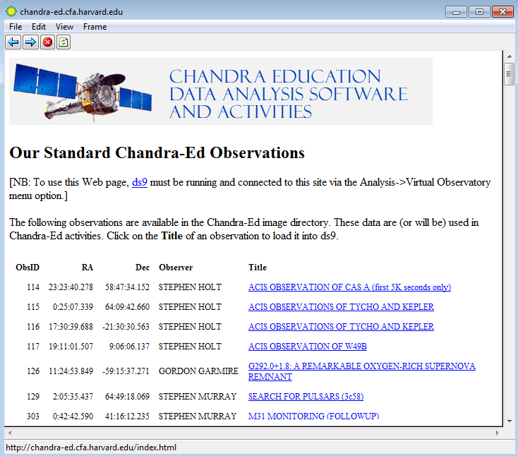
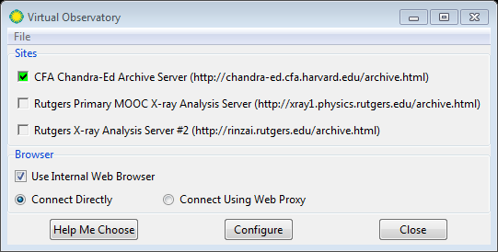
Select the CFA Server. Then choose the ACIS OBSERVATION OF CAS-A image. Now go back to the main window; the image of Cas-A should show up.
Under the Colour menu, Select "b" (or other colour scheme) and "linear" for the Scale. You can right click and drag the mouse on the image to adjust the colour. (This is just to provide a convenient way of looking at the object.)Centre click on the bright dot near the upper left part of the display.

Activity 1: Imaging
Adjust the colour scale to show the details of the remnant. Then export the image by either selecting Save Image under File or screen capture.
Show the image here.

Describe the remnant structure you see in the image.

Activity 2: What is the distance to Cas-A and when did it explode?

Distances are generally difficult to determine in astronomy. The best estimates of the distance to Cas A come from the fast moving knots of material that we can actual see moving outward through the sky over a period of years. The bright spots in Cas A are examples of some of these knots. If we know how fast the knots are moving through space, and we know how far they move in angle across the sky, we can compute the distance to them.

- For knots moving to or away from us, we can determine their radial velocities by the Doppler effect and this is measured to be about 5000km/s. How far do they travel in 10 years?
- For a knots at this speed but moving transversely (i.e. perpendicular to the line of sight), if it is to move 3 arcseconds in 10 years. What is the distance to remnant?
- Suppose this knot is now 100 arcseconds from the centre of the remnant. When did the Supernova explode?

Activity 3: How big is it?

Go back to the image of CasA, and zoom out until you see the entire shell. Select Region->Shape Circle. Click on the centre of the remnant, then drag to draw a circle. Double click at the circle to bring up the information window. Choose WCS arcsec for radius. What is the remnant radius in arcseconds?

Note that this is just a rough estimate since the remnant is not exactly circular and it is hard to define the edge. What is the physical size of the remnant?

Activity 4: Make a light curve

We would like to check if the remnant varied in brightness during the observation.
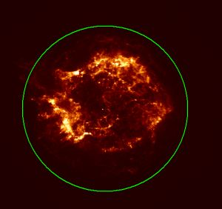

Create a region to enclose the entire remnant.Go to Analysis-->Chandra-Ed Analysis Tools-->Quick Light Curve Plot. Place a value of 32.4104 in the upper part of the dialog box, and check the first box.
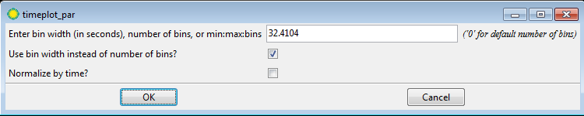
Note: It is very important that time bin that is an exact multiple of 3.24104s, so we can avoid spurious "aliasing" of the intensity. You may try other values to see what happens. (Can you explain why?)
Copy and paste the lightcurve here.
Does the intensity vary with time? Is this real or just statistical fluctuation?

- In the light curve plot, select Graph-->Rangeand change the range of the Y axis to begin from 0 to the maximum value. Uncheck the auto box. Hit OK.
Now look at the same data! Quite a bit smoother, isn't it? So what do you believe? Is the source varying in brightness or not? There are sophisticated statistical tests that we make to show that indeed, the light curve does NOT vary in time, at least within the limitations that we have with the Chandra satellite.
Show the new plot here.
Do you think the fluctuation is physical or statistical? For the latter, we expect N countsto have statistical fluctuation of $\sqrt{N}$. Does the variation you see in the plot imply any flux variability of the remnant?

- Now, try some smaller regions so you can see what happens to the light from little knots of material. Make light curves of these regions. Do they look similar?

- Let's examine the background (regions that do not contain the remnant). For example, the region surrounding Physical X=4080 and Physical Y=4600 is within the field of view of Chandra, but is looking at an empty part of space. What does this light curve look like? What do you conclude?

Activity 5: Radial Intensity Profile

To see the actual distribution of the supernova material, we can look at the intensity of X-rays coming from concentric rings of material, projected onto the sky.

- Select an annulus for your region shape, then click on the centre of the remnant. Click once to create the region, and double click to bring up the information box.
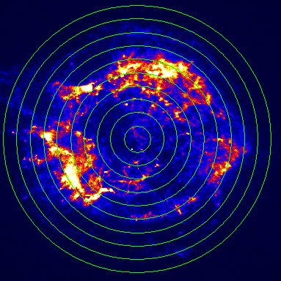
- Set an inner radius of 0 and an outer radius of 3 arcmin, with 10 for the number of annuli.
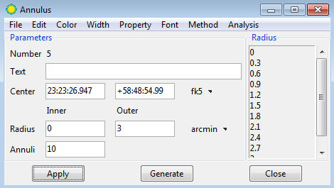
- Click on “generate” and then “apply”. You will notice that 10 concentric rings appear like a bulls-eye surrounding the remnant. What we will find out is how bright the remnant is as a function of how far you are away from the centre.

- Under analysis, click “radial profile”.
Show your plot here.

- Describe the radial profile. What structure of the remnant does it imply? A solid sphere or a shell?

Activity 6: Extract the Energy Spectra

Just as sodium vapor lights are yellow while mercury lights are blue, the energy spectra could tell us what elements are present in the source.

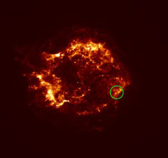
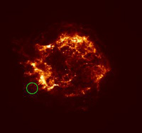
- Set up a circular region(a) near Physical coordinates (X,Y) = (4050,4100). (The position and radius do not have to be exact). This will put a region near the bottom left part of the remnant. Choose AnalysisChandra-Ed Analysis ToolsQuick Energy Spectrum Plot from .1-10 kev to generate a spectrum.
(b)
(a)
Copy and paste the spectrum here.

- Do the same for a circular region (b) near the bottom right of the remnant around (X,Y)=(4530,4176).
Copy and paste the spectrum here.
- Describe the difference between the two spectra and use the table below to infer what elements dominate the two regions.

Energy (keV) | Element
1.0 | Ne + Fe
1.3 | Mg
1.8 | Si
2.4 | S
3.8 | Ca
6.4-6.8 | Fe

- The point source near the remnant centre at Physical coordinates (4291, 4235) is the neutron star in Cas A first detected with Chandra. It is the compact core left over in the supernova explosion. Draw a small circular region with 2 arcsec radius to enclose the neutron star.

Describe the neutron star spectrum and compare it with that of the remnant.
Extract the spectrum and paste below.

- (Optional) The spectra we obtained above are just simple histograms of the detected X-ray photon energies, discuss what corrections are needed if we want to measure the intrinsic source spectrum.

Activity 7: Create a Three-Colour Image

To have a better idea of the distribution of the elements in the supernova remnant, we will generate narrow-band emission line images. We choose Si, S, and Fe lines. As suggested by the table above, we will apply energy filters of 1.65-1.95keV for Si, 2.3-2.5keV for S, and 6.4-6.8keV for Fe.
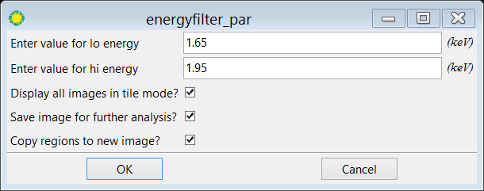
- In the main image window, choose AnalysisChandra-Ed Analysis Tools Energy Filter and enter1.65 for lo energy and 1.95 for hi energy.
This opens a new frame. Click on the new frame and choose FileSave in the menu to save it as a “si.fits” file.
- Delete the frame using Frame Delete Frame in the menu and go back to the original full band Cas A image. Repeat the process above and choose lo energy = 2.3 and hi energy = 2.5, and save the image as “s.fits”.
(Note: it is important to delete the frame and start over from the full band image every time, otherwise, a blank image will be obtained as we try to filter 2.3-2.5keV from data that is only in the 1.65-1.95keV energy range.)
- Do the same for Fe.
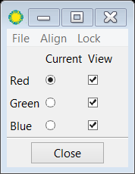
- Now we have three images that shows the distribution of the elements. Although we can compare them side-by-side, it is easier to combine them into a three-color image. Choose FrameDelete All Frames, then FrameNew RGB Frame. A control window will show up.
Choose Red then File Open to load si.fits. Adjust the brightness/contrast using the right mouse button. Repeat the same for Green with s.fits and Blue with fe.fits. You should now have a colour image. You can re-adjust the brightness/contrast of individual colour channel if needed.
- (Optional) You can smooth the image using Analysis Smooth to make it look even better. Be sure to set LockSmooth in the control window.
Show the final image here.
Describe the distribution of the three elements. Do they follow the same distribution? Why or why not?

(optional) Try other combination of elements.

