Measuring the Height of Lunar Craters

Lab Description:
The aim of this lab is to find out the width and height of some craters on the surface of the Moon. The basic idea is to measure the size of the shadows cast by the crater rims. Figure 1 below illustrates the basic idea:

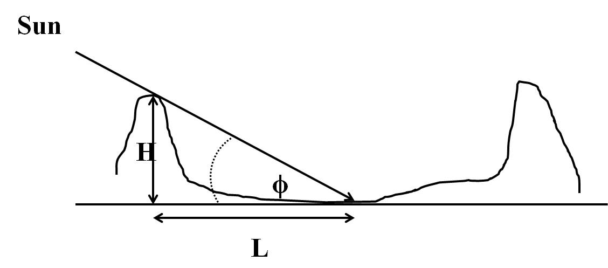
Figure 1

Provided that the solar angle (ϕ) is known, the height of the crater rim (H) can be calculated through a measurement of the crater rim shadow length (L).

Objective:
- Capture images of the lunar surface with appropriate exposure.
- Measure the shadow length of lunar crater rims. Use the measured data to calculate the height of craters.

Additional Objective:
Measure the width of lunar craters with the similar method used in the calculation of the height of the craters.

Instrument:
- OGS 16" telescope (f/8.4)
- Apogee U9 CCD (9×9 microns per pixel)
- Baader ND filters

Planning:
It is better to take the observation around the first quarter (i.e. moon age from 6 days to 8 days), because from Figure 1 we see that if the shadow covers most of the crater bottom, the height H would be too long and would reach the other side of the rim, which introduces large errors in the measurements such that the measured value would be much smaller than the true value. We choose the first quarter to take the measurement when nearly half of the lunar disk is illuminated.

Observing:
Observe the moon with eyes first. Use the Tele Vue 9mm eyepiece to get a maximal magnification around 400×. The moon through the eyepiece under this high magnification would be blurry due to turbulence of the atmosphere. Describe the image you see in your lab report, which would give us an idea of the seeing of the night sky. After that, try different eyepieces.

After eye observation, rebalance the telescope and plug in the CCD. Be careful not to push the telescope as that could mess up the pointing. In case this happens, need to manually slew the telescope using the panel and the finder, and then click “sync” in TheSky program. Also, read out and mark down the moon-earth distance from TheSky 6. You need to take pictures with the focal reducer first to take images of larger field of view, which is easier to locate areas of interest. Stack appropriate ND filters to the CCD tube first. Sometimes two ND filters (3.0+0.6) are needed when the moon is bright (moon age around 8 days). At least two students in a group to focus the telescope (see the manual for focusing in MaxIm DL). Rotate the CCD to align with the terminator. Take several pictures fully covered the illuminated moon surface. Exposure time should not be less than 0.5 seconds to avoid shutter shadow on the image. Try different exposure time to get appropriate exposure. After finish, select the images with the best focus and copy them to your own USB flashdrive.
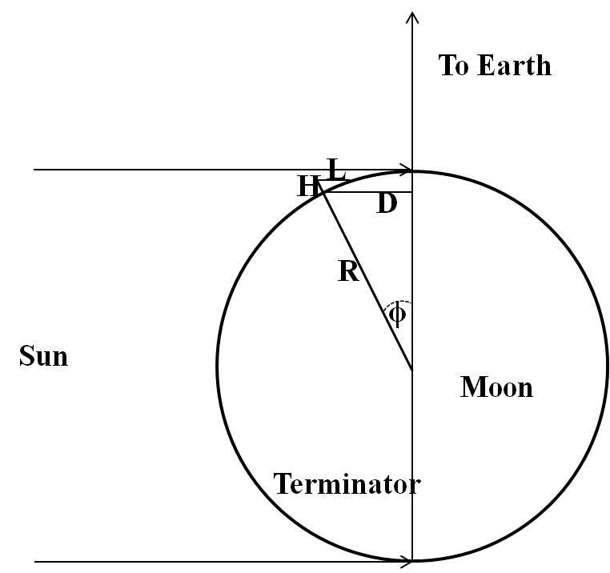
Analysis:
There are two cases we have to consider:
(1) At exact first quarter:

Figure 2

In this case the terminator lies along the direct line to the Earth. Choose a crater with rim shadow of appropriate length. Based on the geometry in Figure 2,

$$\sin{ϕ} = H / L (1)$$
$$\sin{ϕ} = D / R \left(2\right) ,$$

where D is the distance of the far crater rim from the terminator and L is the shadow length cast by the crater rim. R is the radius of the moon. From Equations (1) and (2),
$$H = L × D / R (3)$$

(2) Moon age after the first quarter:
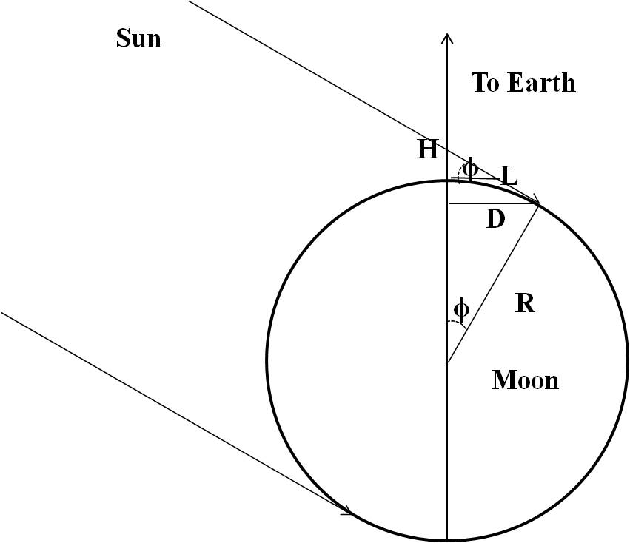
Figure 3

Under these conditions the terminator (the line separating the illuminated from non-illuminated portion of the lunar disk) is not far away from the direct line with the earth. Also the shadow length of craters near the terminator is appropriate for measurement. Our calculation is based on the geometry illustrated in Figure 3:

$$\tan{ϕ} = H / L (4)$$
$$\sin{ϕ} = D / R (5)$$

From Equation (2):
$$ϕ =\sin^{-1}\left(D/R\right)$$
$$H = L ×tan({\sin^{-1}{(D/R))}} (6)$$

Show the full image you took.

Show a zoom-in image and indicate the crater you choose.

Calculation:
- Choose a crater in the image for the measurement. It should clearly show a shadow.
- Measure the crater’s shadow length L, distance from the crater rim to the terminator D, and the moon radius R in pixels. (You need the software ds9 to determine the radius, please refer to the manual at the end of the lab instruction.)

- We need to calculate the plate scale, i.e. how many km 1 pixel corresponds to. The 16” optical telescope has f/8.4, what is the focal length in mm?

The CCD has pixel size of 9micron (i.e. 9x10⁻⁶m), what is the angle 1 pixel correspond to in the sky?

The average lunar distance is 3.84x10⁵km, therefore, how many km 1 pixel corresponds to on the Moon surface?

To check the result, draw a circular in ds9 to determine the radius of the Moon in your image (in pixels). Convert this into km and compare the result with the mean lunar radius of 1737 km. Are they consistent? If not, what are the possible sources of error?

- Check the Moon age of your observation and calculate the height H using the appropriate formula.

- Measure the diameter of the crater in ds9, then convert to km.

- Look up the lunar map on the web to find the crater you chose. Write down the name, diameter, and height. Compare with your results and analyze the source of errors.

Appendix
Techniques:
1. Determine the terminator
As seen from the image shown above, there is no clear line of the terminator. So how can the terminator be identified precisely? We use the Screen stretch to make the line more obvious. Pay attention the green triangle circled by red circle and the reading of Maximum below it.

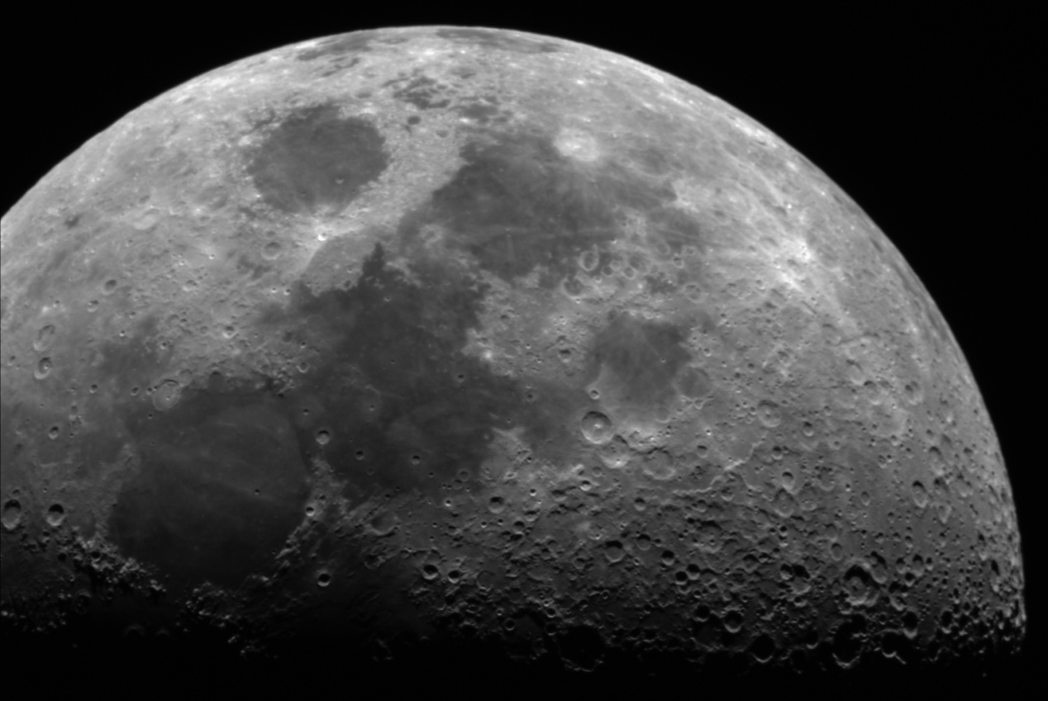
Image shot by the 16″ telescope and Apogee U9 CCD. The moon age is around 6 days.

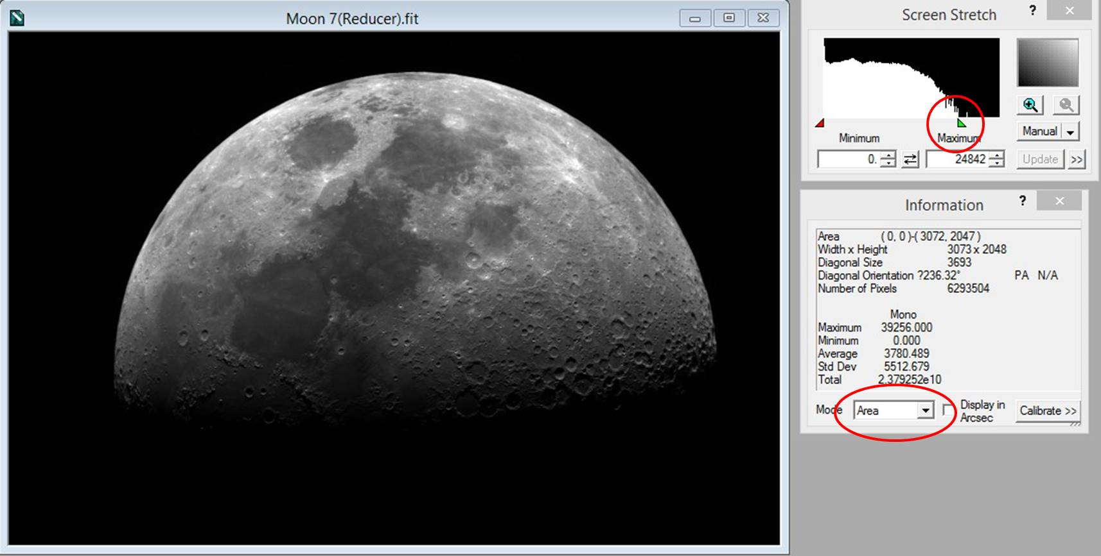

As we drag the green triangle to the left (still right to the red angle, though very closed), the bright part of the image will become white and lose details. A clear terminator shows up as below:

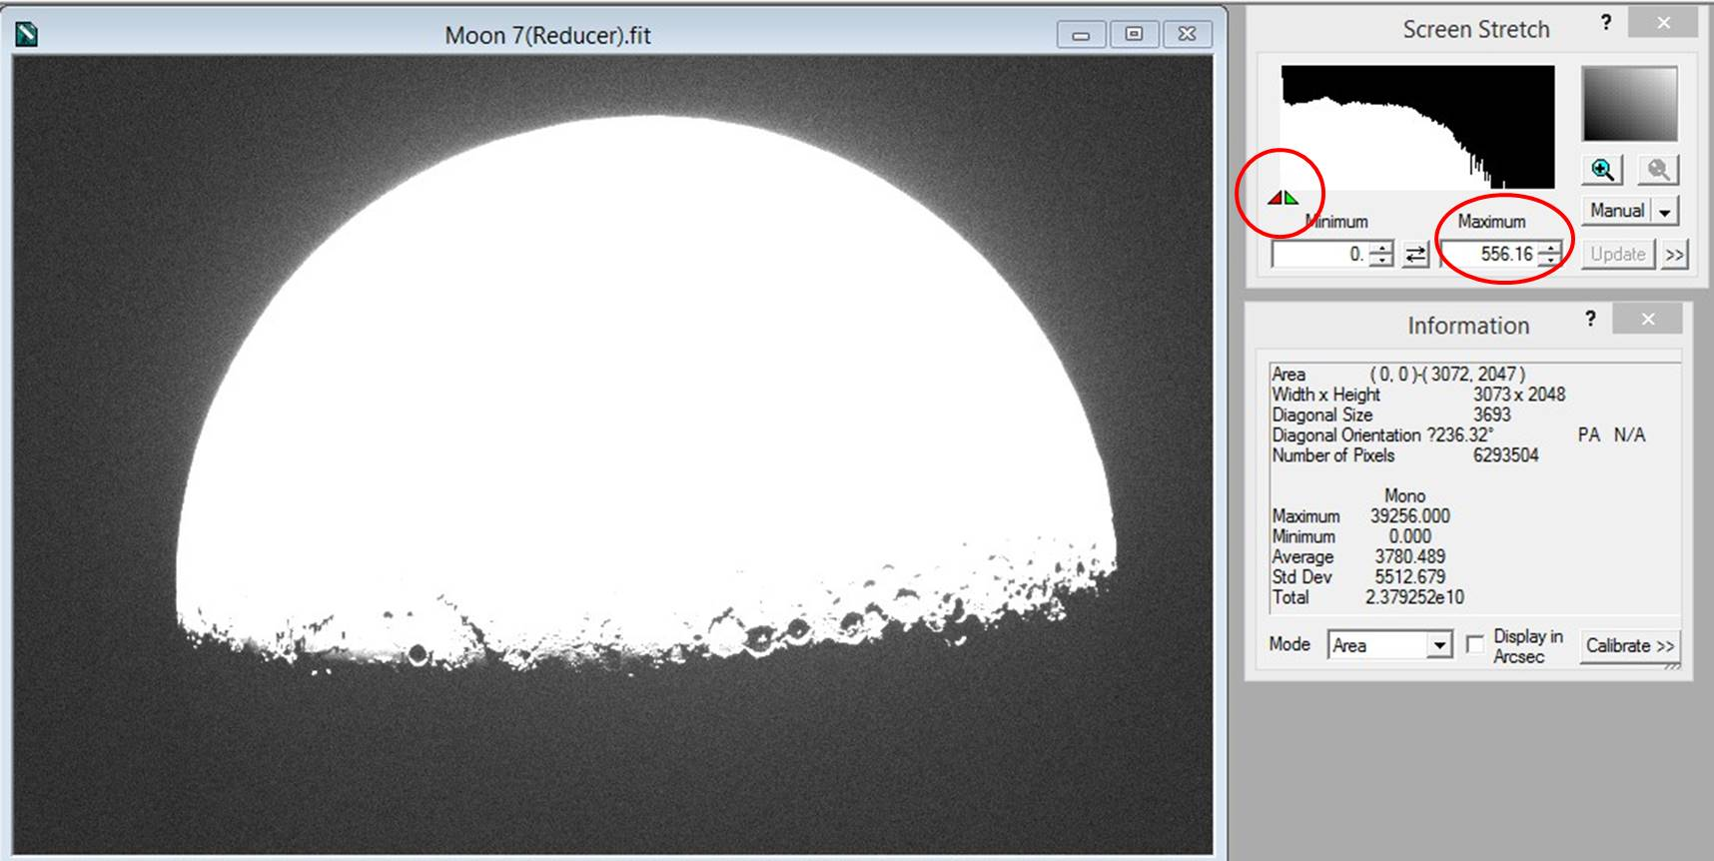

2. Measure the length in pixels with DS9:
Open a image in DS9, zoom out the image to fit the screen. Click “Region” in the manual bar. Choose “Circle” from “Shape”.

Draw a circle to fit the contour of the moon as shown below:
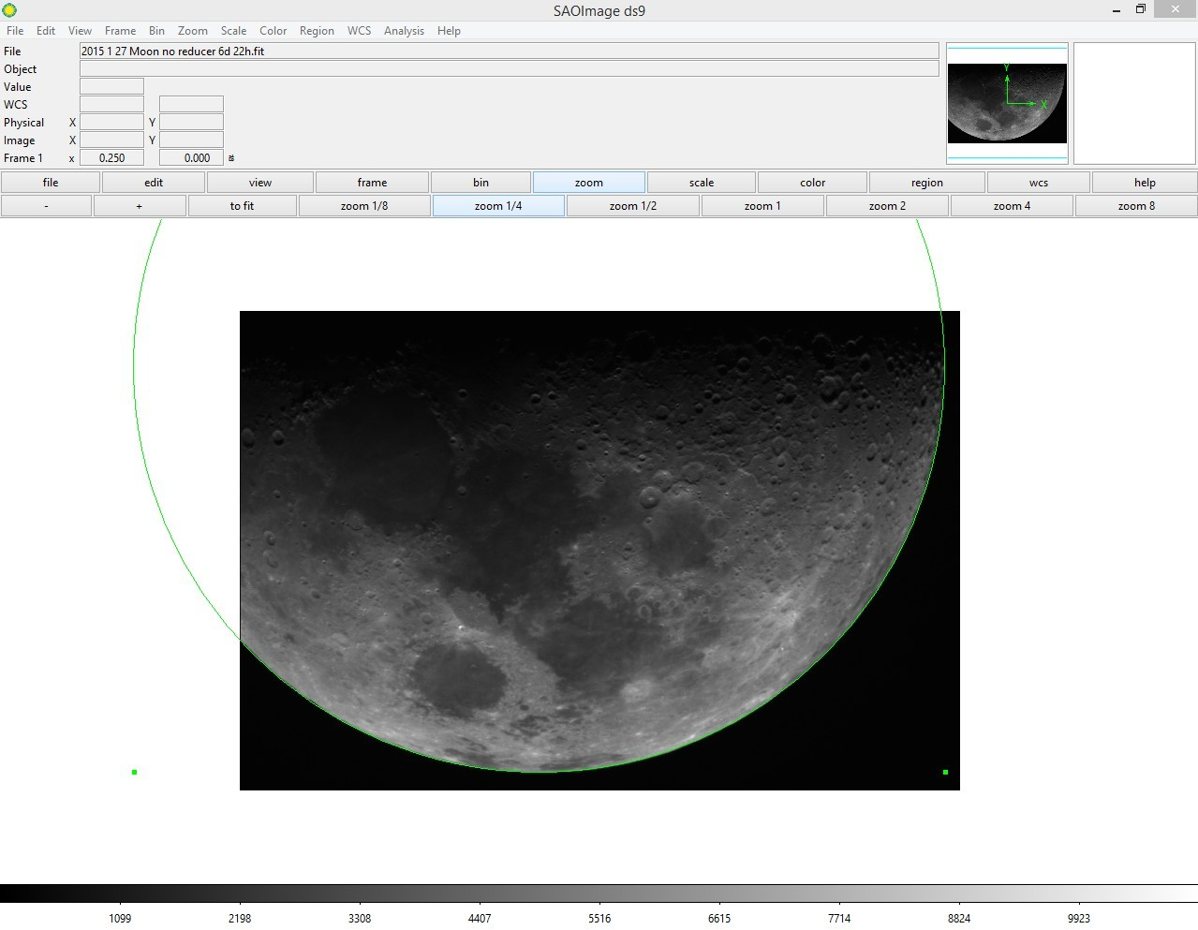
Then double click the circle, “Circle” Information window will pop up, you can read the radius of the circle (which is also the radius of the moon) in pixels. As for the measurement of lines, choose “Line” in the “Shape” manual. Draw a line in the image, double click the line and the “Line” information window will pop up.

Note: you can right click and drag the mouse over the image to change the display brightness and contrast. You can use middle click to centre the image.

3. Online pixel resolution & field of view calculator

http://starizona.com/acb/ccd/calc_pixel.aspx

