Please take me to the University of Hong Kong,
Chong Yuet Ming Physics Building
請送我到香港大學，莊月明物理樓

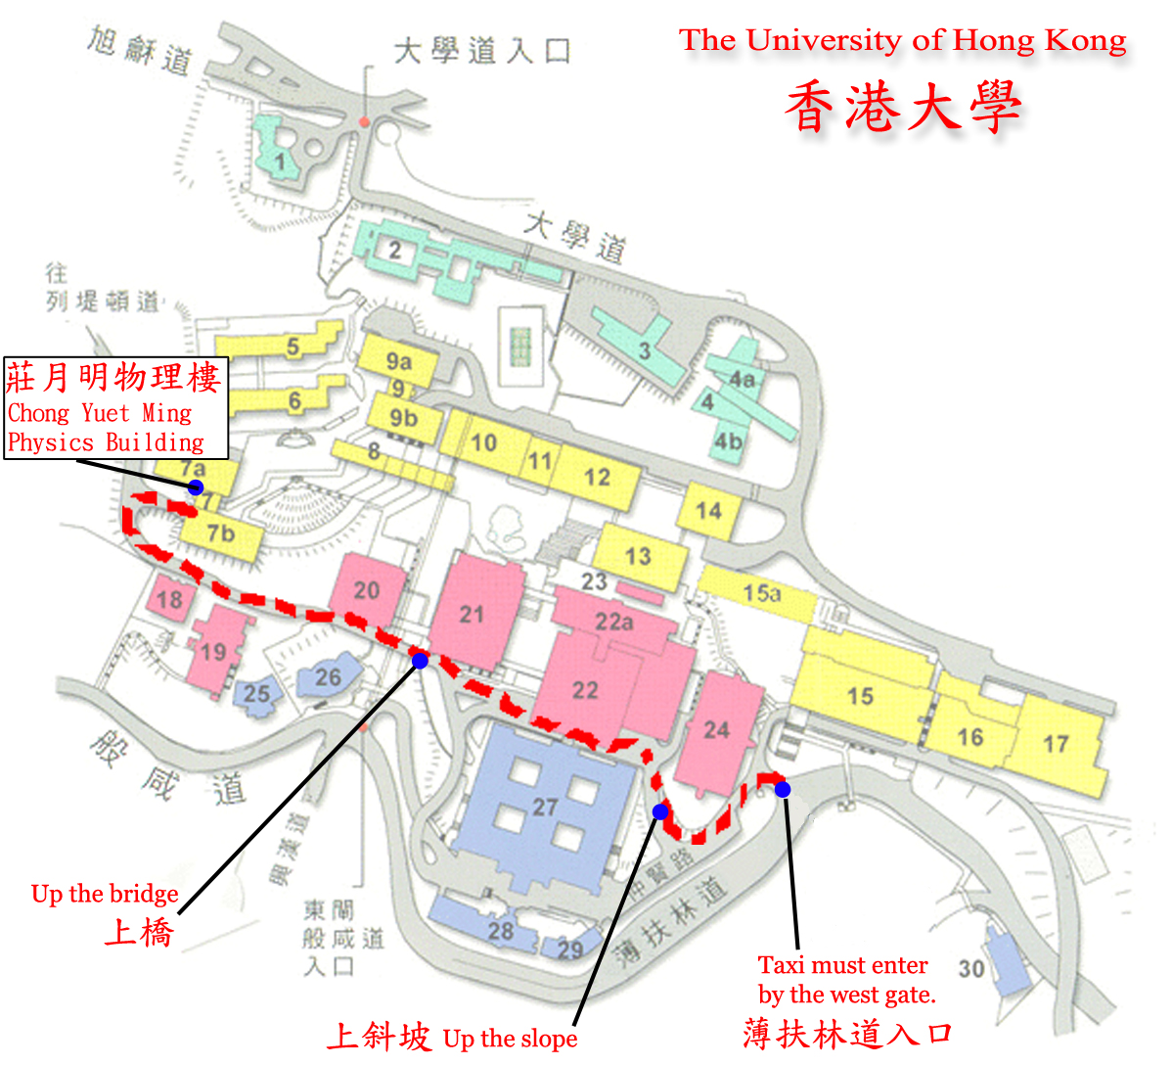
When you get off, you will be on LG3/Floor. Please take the lift to go to the Lecture Theatre P4 on LG1/F.

